**Diana Savchuk**

**Assessment Portfolio**

**SQL: Introduction — DH3J 34**

**SCQF level 7**

**Part 1**

Assessment tasks  
The following SQL Statements should be completed in APEX.  
A screenshot should be taken of each completed statement and the Result. All the screenshots should be put into a Word document with an appropriate title (Task 1 Answer, Task 2 Answer etc....) and submitted to the Assessment Dropbox.  
Please note that all the tasks should be completed before submitting the Word document.

Task 1  
Select all the employees whose last names end with “s”. Change the heading of the column to read Possible Candidates.

Answer 1:

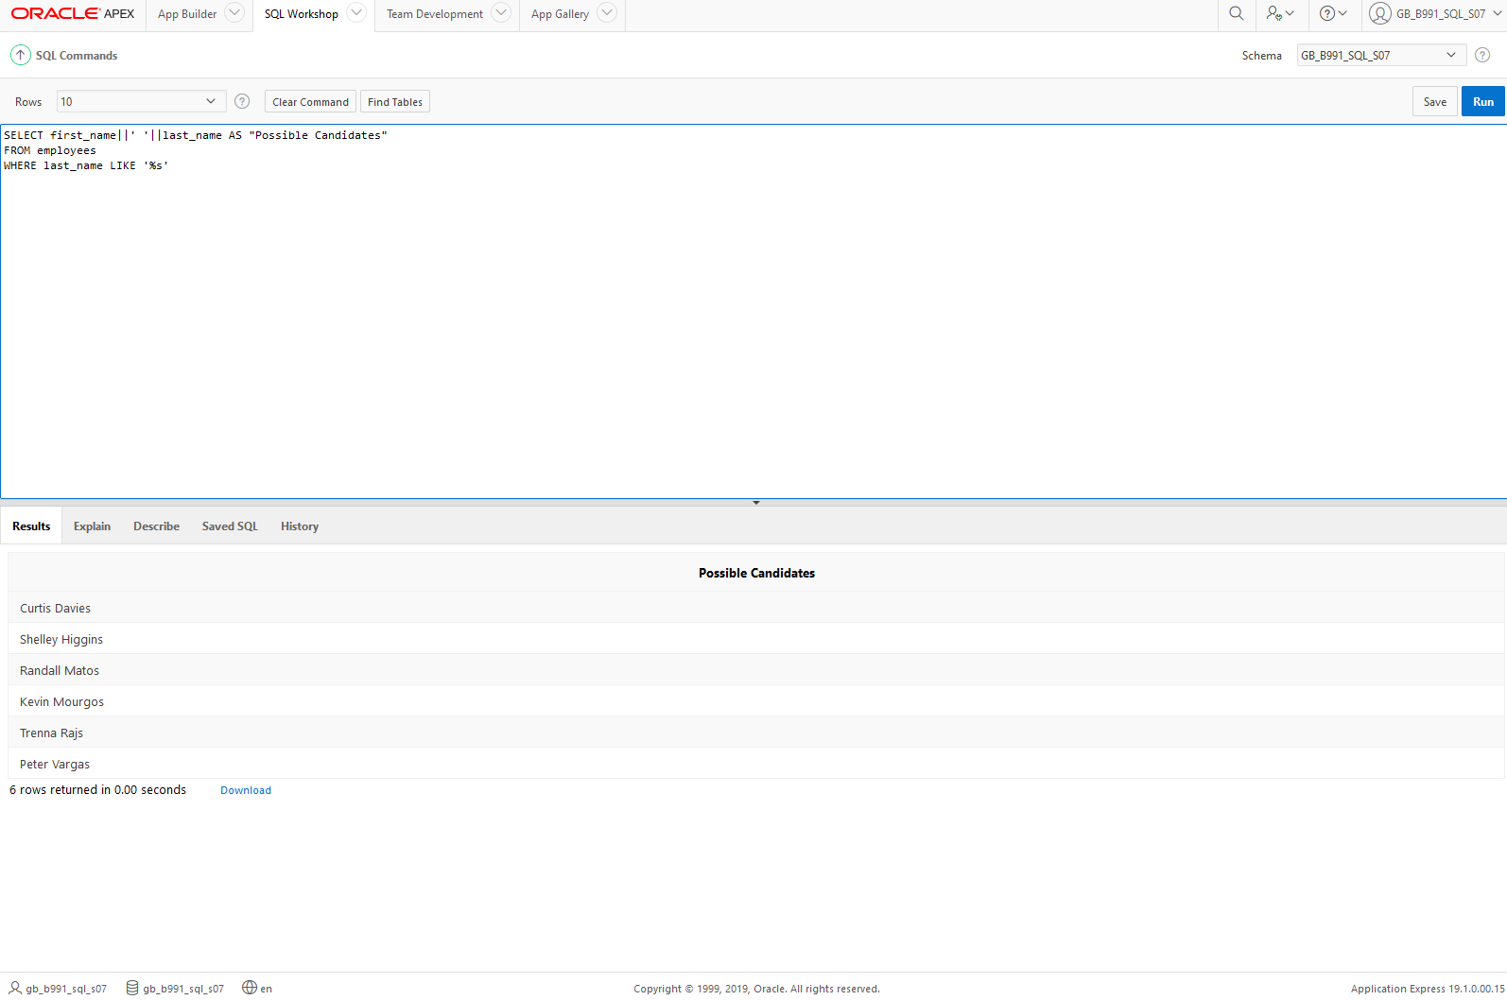

Task 2

Using the employees table, write a query to display all employees whose last names start with “D” and have “a” and “e” anywhere in their last name

Answer 2:

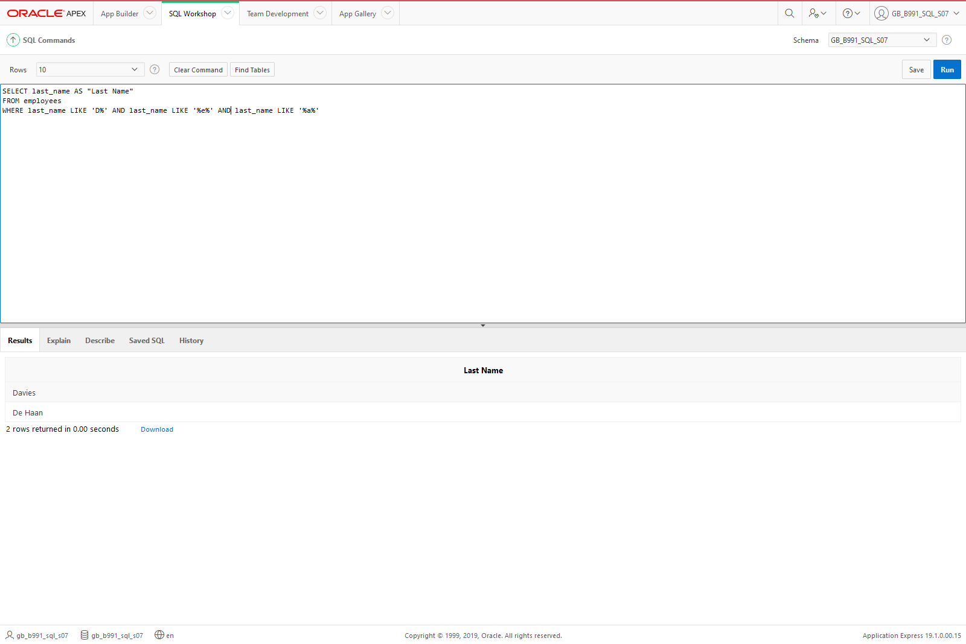

Task 3  
Create a query that will return all the DJs on Demand CD titles ordered by year with titles in alphabetical order by year.

Answer 3: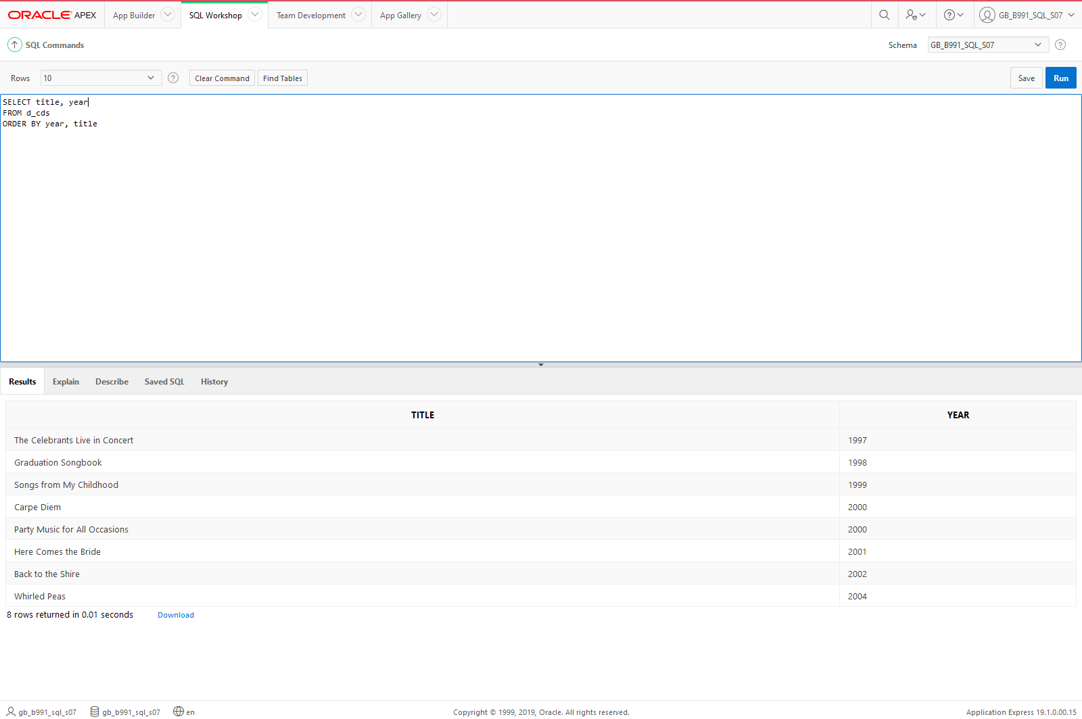

Task 4  
Write a query that will output a column called “ADDRESS” which has the following information: ZOE TWEE 1009 OLIVER AVENUE BOSTON, MA 12889. Use the Global Fast Foods F_CUSTOMERS table

Answer 4: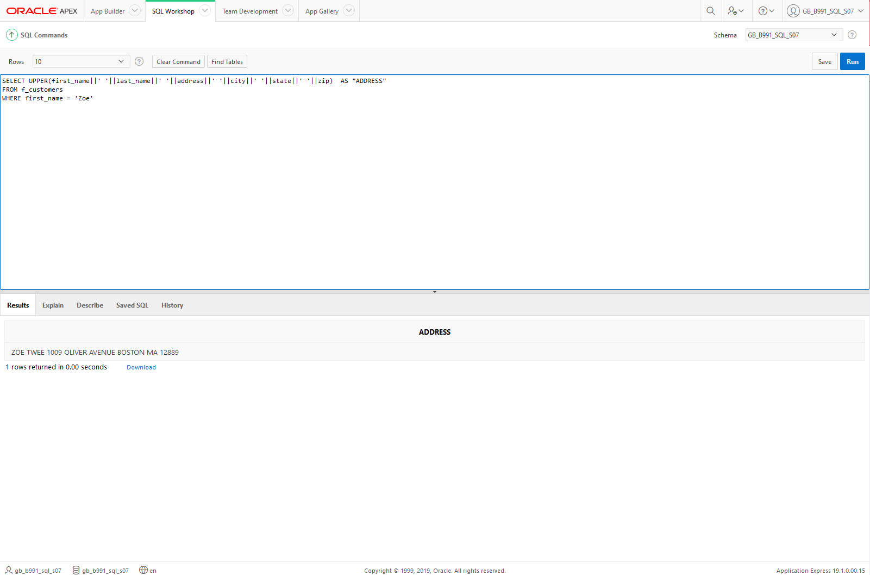

Task 5  
Display Oracle database employee last_name and salary for employee_ids between 100 and 102. Include a third column that divides each salary by 1.55 and rounds the result to two decimal places.

Answer 5: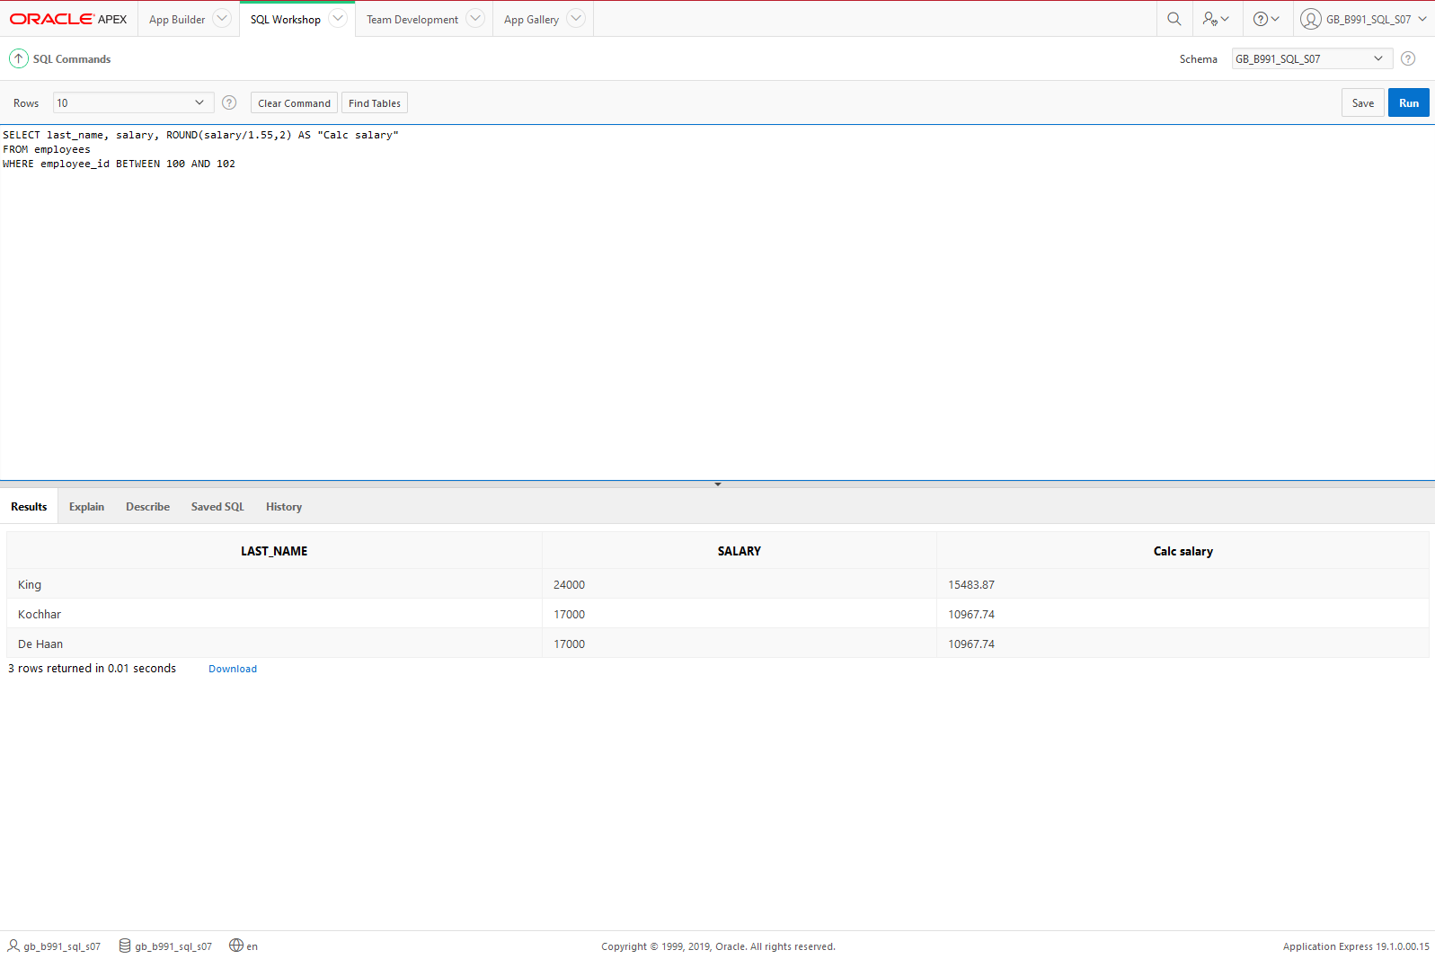

Task 6  
Display employee last_name and salary for those employees who work in department 80. Give each of them a raise of 5.333% and truncate the result to two decimal places.

Answer 6: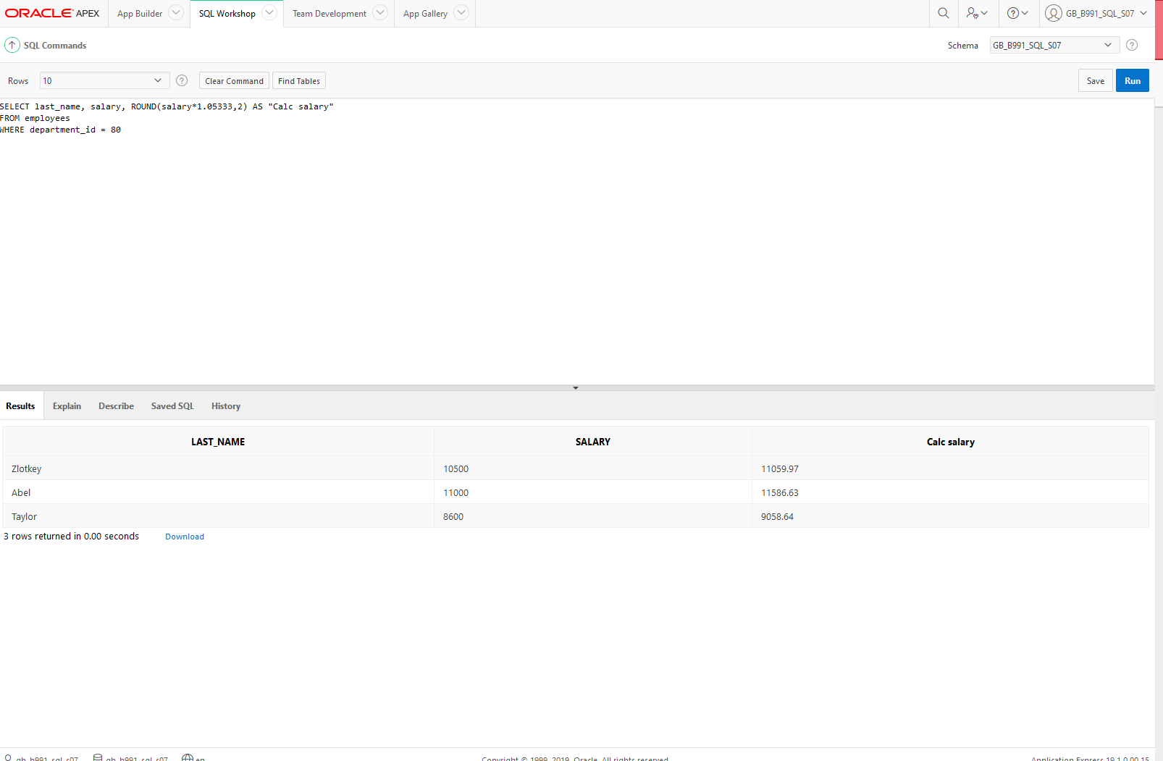

Task 7  
Write a SQL statement using the employees table and the ORDER BY clause that could retrieve the information for all employees who were hired after 01 st Jan 1993 who have the job title SA_REP and order by their surname in ascending order.

Answer 7: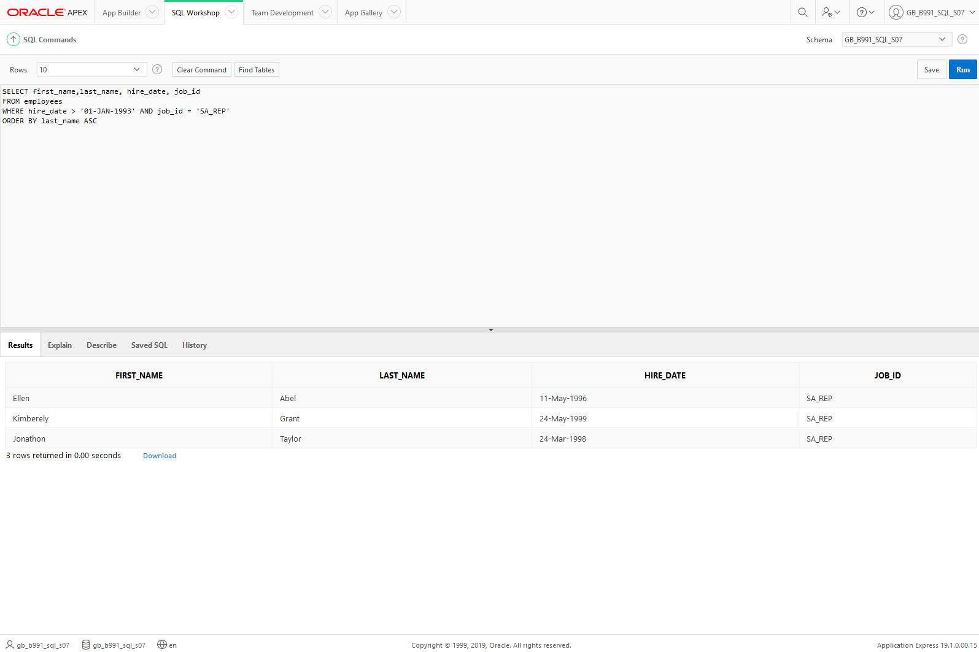

Task 8  
Using the Department table, write a query to display all departments that end in ‘ing’. Or start with an E.

Answer 8: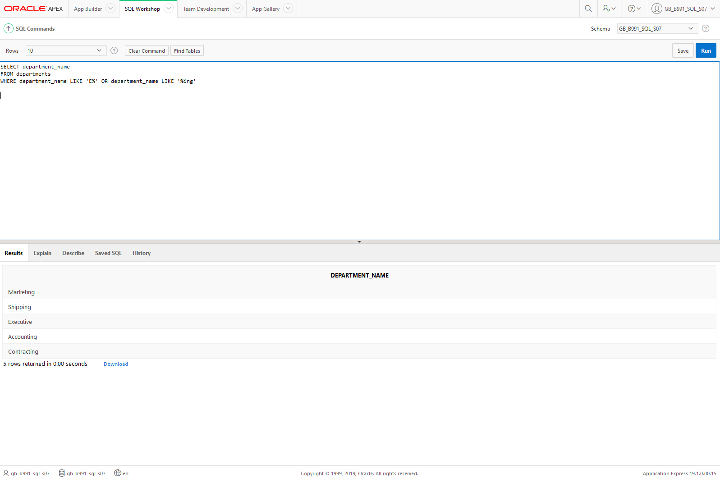

Task 9  
Create a username for everyone in the employees table. Use the first letter of their first name and surname and then give the output title “USER NAME”

Answer 9: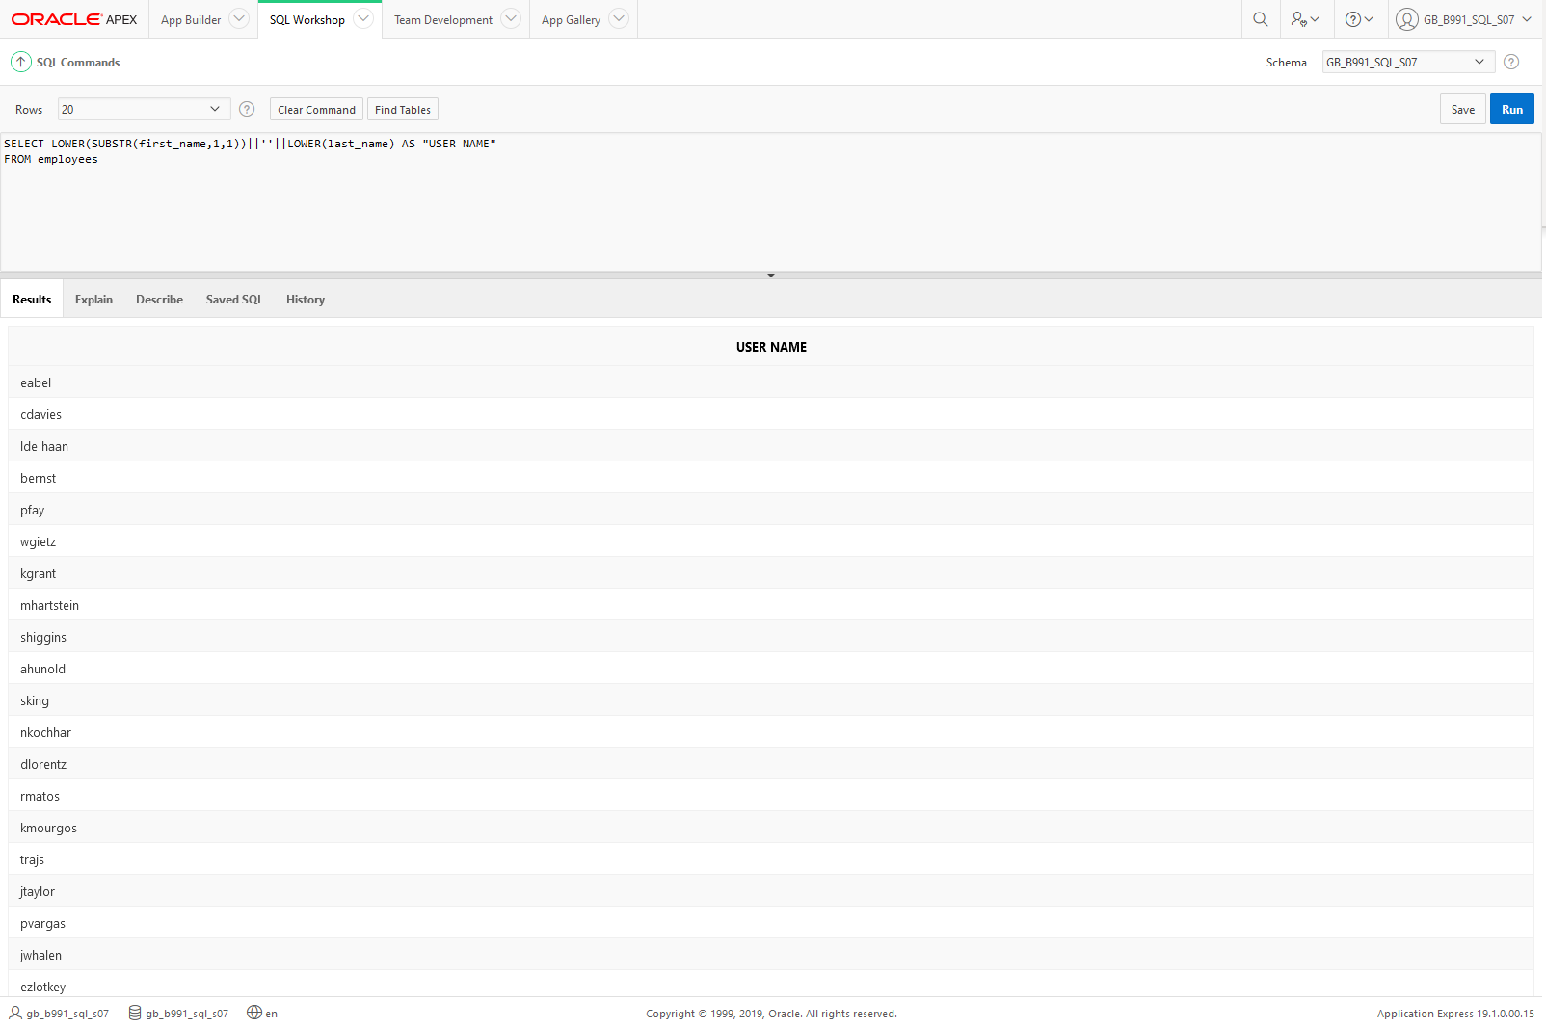

Task 10  
For Orders, display the number of months between the order date today’s date. Round to the nearest month.

Answer 10: